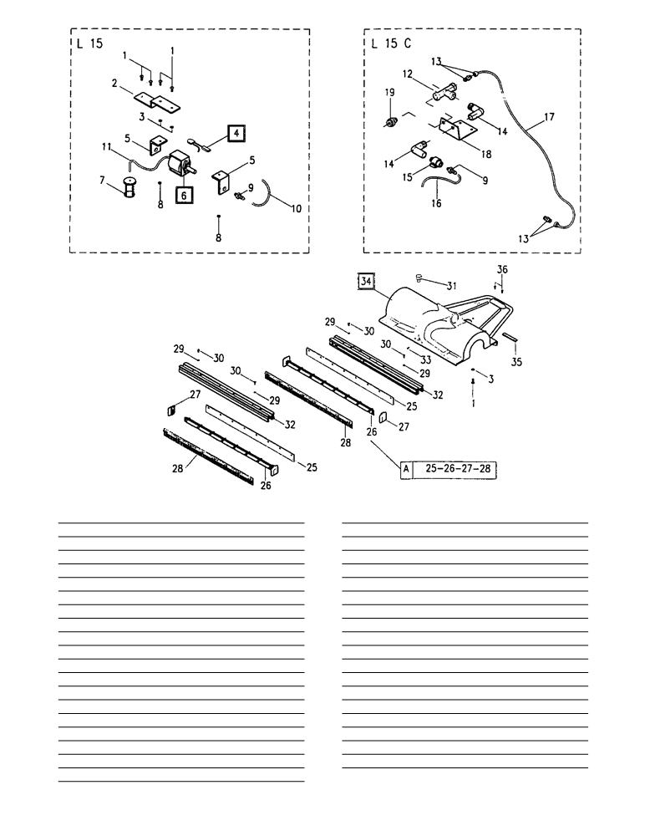

Ref. | SKU | Description | Qty. |  | Ref. | SKU | Description | Qty.
1 | E86903 | AS30/36 Screw M.4-16 | 9 |  | 20 | 1255028 | 1/8" 6x8 union elbow | 1
2 | E89288 | Pump support bracket | 1 |  | 21 | 1255034 | 1/4" 6x8 union elbow | 1
3 | 1108807 | Washer, uni 6593 4x16 | 11 |  | 22 | 25002023 | Supplementary pipe | 1
4 | E89417 | Thermal Protection | 1 |  | 23 | 25002022 | Water pipe for brush | 1
5 | E89289 | Pump vibration support | 2 |  | 25 | E89018 | Blade, Squeegee Outer | 2
6 | E89012 | Solution Pump for GS15 | 1 |  | 26 | E89031 | Blade Support GS15 | 2
7 | E89028 | Solution filter GS15 | 1 |  | 27 | E89032 | Squeegee Cap GS15 | 2
8 | E89348 | Nut M4 | 2 |  | 28 | E89019 | Blade, Squeegee Inner | 2
9 | E85587 | Fitting 1/8" x 1/4 hose barb | 1 |  | 29 | E89083 | Washer | 9
10 | 25002032 | Supplementary pipe | 1 |  | 30 | E89033 | Screw 3.5 x 19 | 4
11 | E89069 | Solution Tube | 1 |  | 31 | E86399 | squeegee adjust spring guide GS15 | 1
12 | 1255010 | 1/8" FFF union tee | 1 |  | 32 | E89034 | Squeegee Pad Support GS15 | 2
13 | 1255009 | Straight male pipe fitting, 8x6 1/8" | 2 |  | 33 | 1105500 | Screw, uni 5931 5x12 | 1
14 | 1255007 | 1/8" MF union elbow | 2 |  | 34 | E87797 | Suction chute GS15 | 1
15 | 1320088 | Mini 1/8" ball valve | 1 |  | 35 | E89134 | Fixing bracket GS15 | 1
16 | 25002009 | Water pipe for brush | 1 |  | 36 | E89024 | Screw ISO 7380 5 x 12 | 2
17 | E89135 | Supplement pipe | 1
18 | 22602012 | Accessory support bracket | 1 |  | A. | 23102023 | Complete KIT squeegee
19 | 1255025N | 1/8" small coupling | 1

